Installing Nagios 4 on Ubuntu 20.04 requires several steps, including installing prerequisite software, downloading Nagios 4, configuring Nagios, and installing the Nagios plugins.

1. Installing Prerequisites
2. Download Nagios Core and Nagios Plugins
3. Install Nagios Core
4. Install Nagios Plugins
5. Configure Nagios
6. Verify Nagios Configuration
7. Install and Configure Apache
8. Access the Nagios Web Interface
9. Add Password for Nagios Web Interface (Optional)

Step 1: (First update the system with latest security updates and packages)

# sudo apt-get upgrade && sudo apt-get update -y

Step 2: install the necessary packages that are required to build and install Nagios 4

# sudo apt install -y wget build-essential apache2 php openssl perl make php-gd libgd-dev libapache2-mod-php libperl-dev libssl-dev daemon autoconf libc6-dev libmcrypt-dev libssl-dev libnet-snmp-perl gettext unzip

Step 3: Download Nagios 4

# cd /tmp

# wget <https://assets.nagios.com/downloads/nagioscore/releases/nagios-4.4.6.tar.gz>

Step 4: Create Nagios User & Group

# sudo useradd nagios

# sudo groupadd nagcmd

# sudo usermod -a -G nagcmd nagios

Step 5: Extract and install nagios 4 archieve

# tar -xzf nagios-4.4.6.tar.gz

# cd nagios-4.4.6

Step 6: Configure & Install Nagios 4

# sudo ./configure --with-httpd-conf=/etc/apache2/sites-enabled

# sudo make all

# sudo make install

# sudo make install-init

# sudo make install-commandmode

# sudo make install-config

# sudo /usr/bin/install -c -m 644 sample-config/httpd.conf /etc/apache2/sites-enabled/nagios.conf

Step 7: Configure Apache

# sudo a2enmod rewrite

# sudo a2enmod cgi

# sudo systemctl restart apache2

Step 8: Install the Nagios Plugins

# cd /tmp

# wget https://nagios-plugins.org/download/nagios-plugins-2.3.3.tar.gz

# tar -xzf nagios-plugins-2.3.3.tar.gz

# cd nagios-plugins-2.3.3

# sudo ./configure --with-nagios-user=nagios --with-nagios-group=nagios --with-openssl

# sudo make

# sudo make install

Step 9: Verifying Nagios Installation by check our system services

# sudo /usr/local/nagios/bin/nagios -v /usr/local/nagios/etc/nagios.cfg

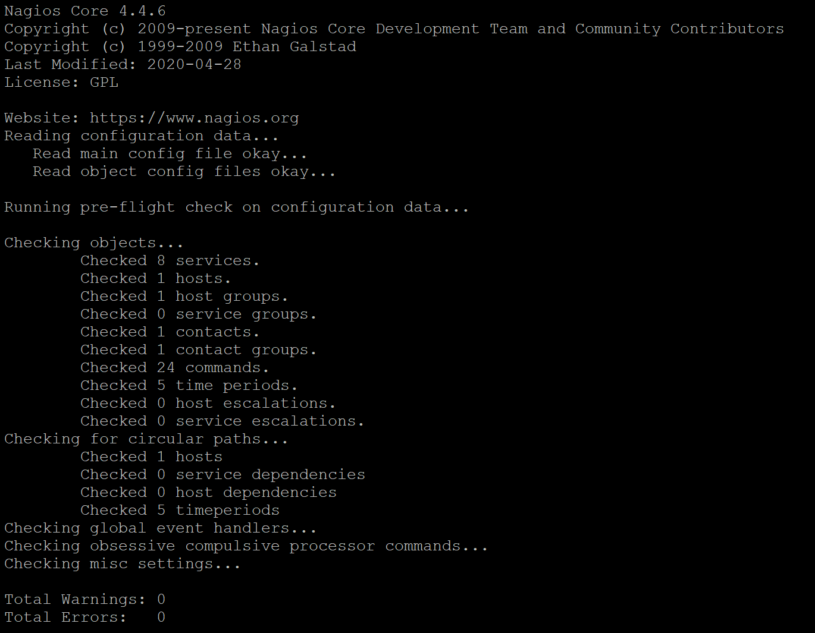

Step 10: Start Nagios & Apache services

# sudo systemctl enable --now nagios.service

# sudo systemctl restart apache2.service

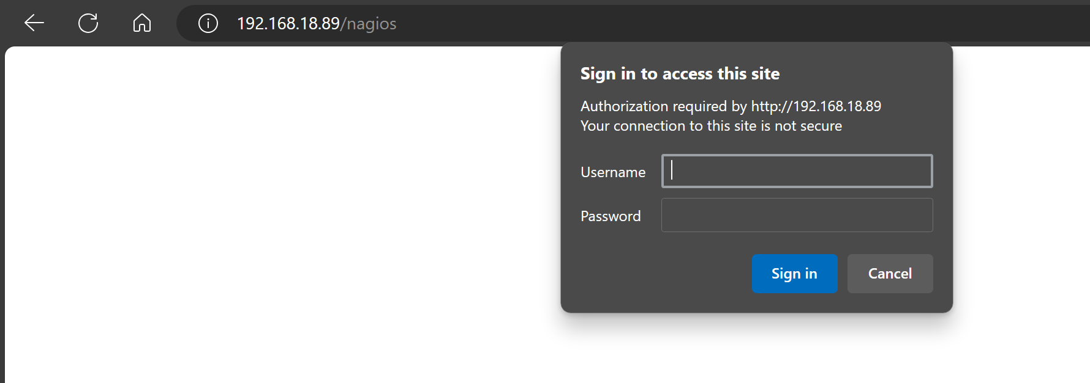

Step 11: Adding Passwd for webinterface

# sudo htpasswd -c /usr/local/nagios/etc/htpasswd.users nagiosadmin

